Name: Jagtap Shivraj Vaibhav
Roll no: EN24107060
Class: SY- AI&DS – A
Subject : Robotics and Automation (MDM)

Experiment no :3
Title: Simulation of Spherical robot configuration using RoboDK Software.
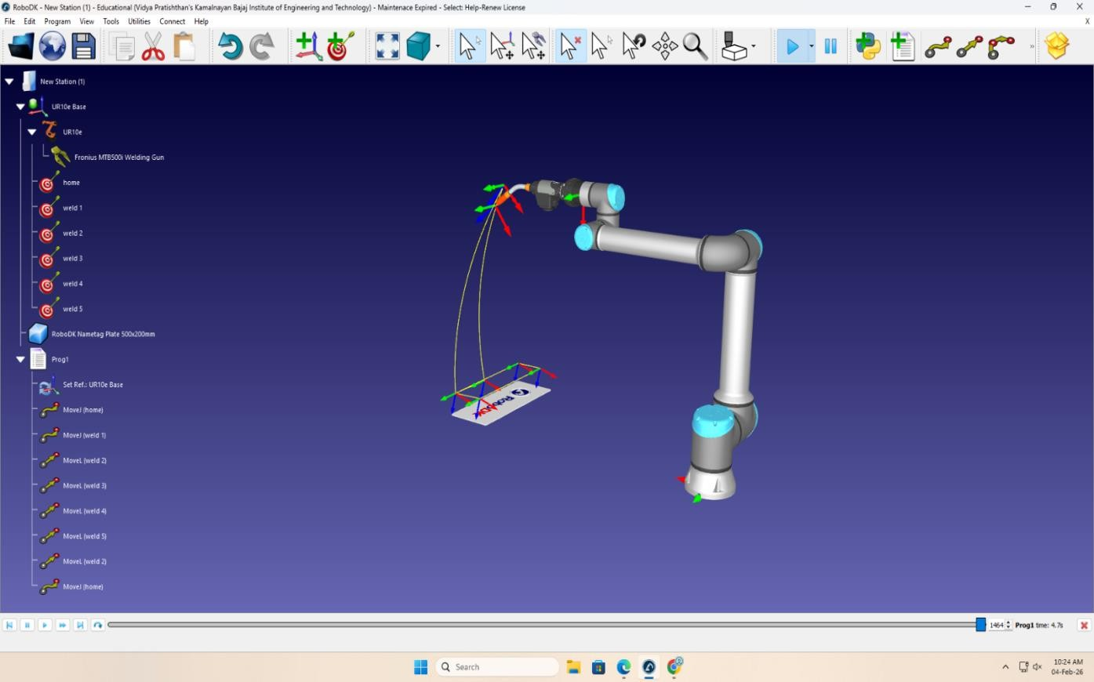

❖

Selected Robot:

UR10e – Universal Robots Why Selected?
- 6 DOF articulated robot
- High flexibility
- Suitable for welding applications
- Easy offline programming in RoboDK
- Industrial collaborative robot

❖ Selection of Gripper:
Tool Used:
Fronius MTB500i Welding Gun
Why?
- Specifically designed for robotic welding
- Accurate arc welding ▪ Suitable for metal nameplate welding Tool is attached to robot flange.

❖ Selection of objects:
Object Used:
RoboDK Nameplate 500×200 mm Purpose:
Robot performs welding along marked paths.
created multiple weld targets:
- weld 1
- weld 2
- weld 3
- weld 4
- weld 5

❖ Explain the procedure of marking Targets:
Steps Followed:
- Insert reference frame on workpiece
- Move robot to first weld point
- Click Add Target
- Rename target (weld 1, weld 2…)
- Repeat for all weld points
- Set orientation so torch angle is correct

❖ Explain the procedure of marking Instructions:
Procedure of Marking Instructions:
In Program
- MoveJ (home)
- MoveL (weld 1)
- MoveL (weld 2)
- MoveL (weld 3)
- MoveL (weld 4)
- MoveL (weld 5)
- MoveJ (home)
Why MoveL for Welding?
Because welding requires:
- Straight line motion
- Constant speed
- Smooth path
Instruction Types Used:
- MoveJ → for positioning
- MoveL → for welding path

❖ Explain the procedure of marking programs:
Steps:
- Right click robot → Add Program
- Add MoveJ to Home
- Add MoveL for each weld target
- Add final MoveJ to Home
- Run simulation Simulation Result:
Robot follows curved yellow trajectory to perform weld path.

Conclusion:
- This experiment provided practical knowledge of simulating a robotic system using RoboDK software. The configuration and operation of the UR10e industrial robot were studied, along with its suitability for welding applications due to its 6 degrees of freedom and high flexibility.
- The selection of an appropriate welding tool (Fronius MTB500i) and workpiece demonstrated the importance of choosing compatible hardware for specific industrial tasks. The process of creating targets, defining instructions, and developing a complete robot program helped in understanding robot motion planning and path execution.
- Additionally, the use of MoveJ and MoveL instructions highlighted the significance of selecting proper motion types for different operations, especially the need for linear movement in welding for accuracy and consistency.
- Overall, the experiment enhanced understanding of robotic simulation, offline programming, and industrial automation processes, which are essential skills in modern robotics applications.

